

**Deliverable 1**

**Open Source Plastic Recycling Machine**

**Date :** 16/11/2021

**Groupe N° :** 14

**Names :** BIANCIOTTO Tom/CLAVEL Maxime/GASTON Louis/LEGARDEUR William/LENNE Margaux/WILLIE Nsongurua Innocent

**SUMMARY**

**A.** **Context of the study** **3**

1. Global context 3
2. Local context 3

**B.** **Problem statement** **5**

1. Germain LEMASSON’s Challenge (our client) 5
2. The Physiotherapist’s Challenge 6

**C.** **Main objective of the project** **7**

1. Objectives for the Shredder 7
2. Objectives for the Press 9

**D.** **Delivery** **10**

**E.** **State of the Art** **11**

**F.** **Workplan** **15**

**REFERENCES** **16**

# **Context of the study**



## Global context

Ecological problems have been taken into account more and more in every aspect of our life. People are aware of the ecological crisis and are searching for some more sustainable way to develop and fabricate new products. In this logic, there is some new way to design a product in order to reduce the negative impact on the environment by choosing adequate materials for example, or using less material. One of the ways to design in a more sustainable way is the **low-tech philosophy**. A low-tech product is a product which answers a need with the least technology possible. The idea is to minimise high technology which is expensive, difficult to repair, and generally use more resources and replace them with low technology and a clever design. This sobriety in the design permits cheap products to be easily made, maintained and used.

Another dynamic in conception that could be explored is “**Open Source**”. It promotes sharing of knowledge by giving everyone the access to the plans, the possibility to modify it and/or make the object themselves from an Open Source Project. This Open Source documentation has to be protected with a license. To give an example, Precious plastic is an association which gives plans to make “do-it-yourself” Plastic Recycling devices. This way of working permits everyone to set up their own Plastic Recycling point at home.

These new trends were popularized by 3D printers which spread all around the world and made it easy to create and make plastic objects. This new technology greatly enhances the development of the low-tech community because people try to make unique objects with 3D printed parts and share them. 3D printing makes the parts fabrication so easy that sometimes people do not pay attention to their designs, therefore printing bad parts which goes directly to the trash and are not recycled. Moreover, the process of melting plastics consumes energy which leads to another resource being wasted.

This kind of plastic waste is just a drop of water among the ocean of global plastic wastes which is catastrophic nowadays. Industries make a lot of plastic waste and only a few are really recycled. It is now an important challenge for the future to find ways to use less plastic and recycle more at the same time.

## Local context

In a more specific case in Grenoble, the **RAFU network** (“Réseau des Ateliers de Fabrication Universitaire”) is a group of research labs and FabLabs that are united in order to collaborate to share means of production. One of the issues that RAFU tries to proffer solutions to is the “management of plastic waste created among the different laboratories”.

To find solutions, the **FabMSTIC**, member of the RAFU network, had bought a complete set of devices that can shred, dry, and recycle plastic into 3D printing filament [*see figure 4*]. Actually, this solution is used very occasionally. It suffers from poor flow of plastic waste and a long process. Moreover, the available plastic wastes need to be broken manually to fit in the shredder. This solution needs to be optimised in order for it to be efficient for the whole network.

In Grenoble’s region we have access to numerous plastic waste resources. The one which could provide the biggest quantity of plastic waste is the **company Chabloz**, specialised in prosthetics. They could provide a huge quantity of polyamide powder (700kg), which comes from their specific 3D printers.

Another interesting contact is **Manuel FRANÇOIS**, a Physiotherapist who makes Orthosis to help people that suffer from hand injuries or handicaps. His activity results in him using lots of thermoplastic to shape the Orthosis. He creates lots of waste due to the complex shapes he has to make. Mr François works also at the Grenobles’s CHU, so he can also give us the waste made there. These thermoplastic plates are very expensive, selling around 100€ for less than a 1m².

The group had the chance to benefit from the experiences of **Sarah LIEDO** on recycling the plastics to plates. Different kinds of plastic were tested with different ways of modeling. We also benefited from the work of **Guillaume MARIN**, who gave us his plastic shredder and a prototype of a hot press that could serve as a great beginning for our project

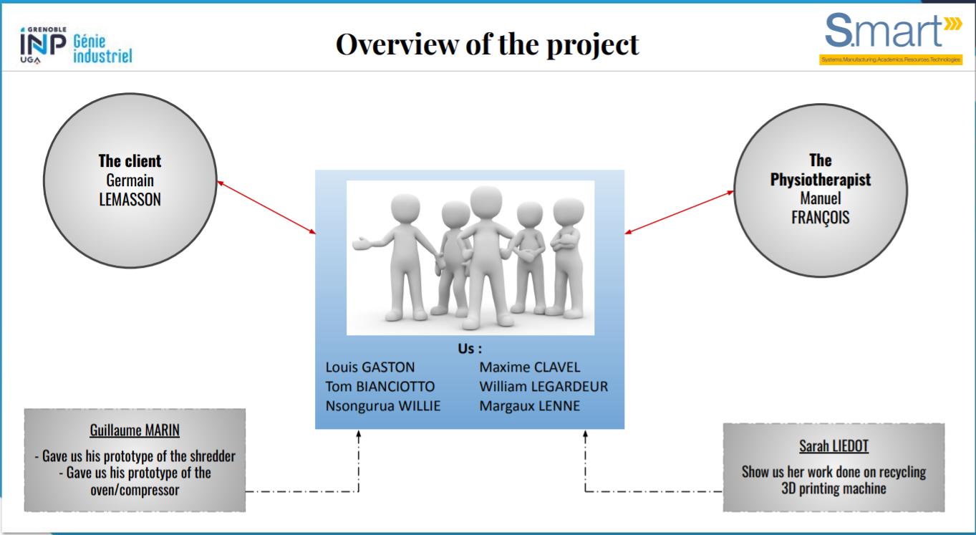

*Figure 2 : Overview of the actors of the project*

To conclude this part, it can be said that the global context has led the group to think of a way **to recycle plastic in an Open Source and Low-Tech strategy**. The solution could be based on the work of Sarah and Guillaume and the final result has to integrate the RAFU network. This conclusion leads to the following section where we will precisely define the Objective of the Project.

# **Problem statement**

## Germain LEMASSON’s Challenge (our client)

Our client is named **Germain LEMASSON**. He is the Manager of the FabMSTIC which is the first significant FabLab on the Saint Martin d'Herès campus of the University of Grenoble. As it is a University FabLab. It welcomes multiple types of people: students and teachers from the various departments and engineering schools of the Grenoble Alpes University, Entrepreneurs, Researchers, Doctoral Students, and anyone who wants to work on and/or innovate technological projects.

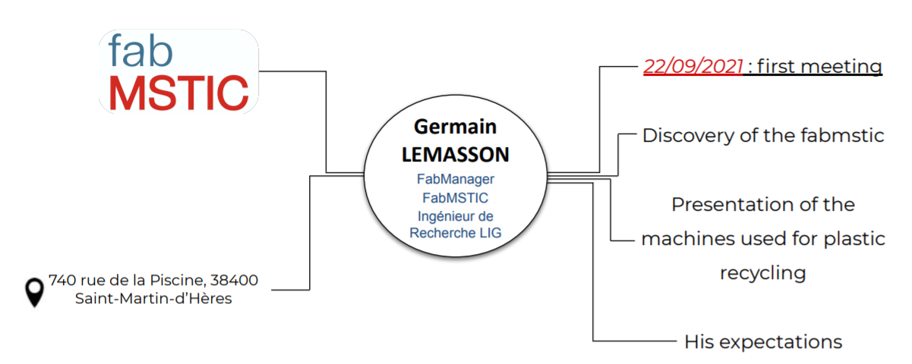

*Figure 3 : Presentation of the client*

Currently, there are already 3 machines in the FabMSTIC to recycle plastic. These machines can, for example, transform INP Students’ plastics from 3D printing scraps into new filaments which will be used to remake parts in 3D printings. The first one is a **shredder** to make small plastic chips of ABS or PLA plastic. Then we put these small plastic chips in a **dryer** which dries up to 1kg of plastic chips within 3 hours. The last step is to make a new filament from these pieces of plastic thanks to a **filament maker**. Below are the images of these machines :

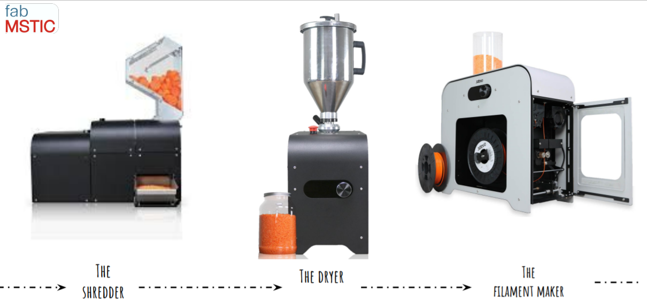

*Figure 4 : 3Devo recycling solution*

However, Mr LEMASSON encounters challenges, and it is here that our project group comes in. Indeed, as seen in part A, these machines are very expensive and therefore do not fit directly into the **low-tech** philosophy desired by the customer. Furthermore, these machines are not used often because they are very recent and therefore still in the testing phase and it takes very long to make small chips with plastic. The hopper of the shredder being very small, Mr LEMASSON must first cut the pieces of plastic to be shredded so that they can be fed into the hopper. In the end, it will take long hours to get the 1kg of small plastic chips needed to make a filament. However, like any investment, it is necessary to make it profitable by recreating a maximum number of filaments. Our role is therefore to finalize the design and create an assembly of low-tech solutions given by **Guillaume MARIN**, an engineer, for grinding. Thanks to our low-tech shredder we will be able to shred big chips of plastics and give them to FabMSTIC therefore enabling Mr. Lemasson to make smaller chips of plastic faster and facilitate the creation of filament.

## The Physiotherapist’s Challenge

In parallel, we will work with a Physiotherapist/Orthotist of Grenoble named **Manuel FRANÇOIS**.

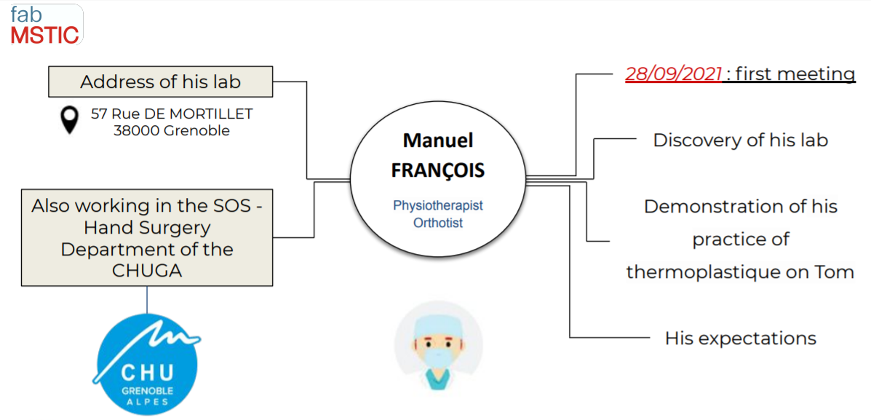

*Figure 5 : Presentation of the physiotherapist*

His job as an Orthotist consists of creating splints using the thermoforming technique. These splints allow the immobilization of joints in case of fracture, the resting of joints such as Osteoarthritis. It also gives protection from surgery and promotes proper functioning of the hand by facilitating activity and maintaining it in an adapted position. In order to make such a splint, the Orthotist uses thermoformable plastic which he softens in hot water (between 60 and 70 degrees) and moulds it on the patient's hand.

-------->-------->

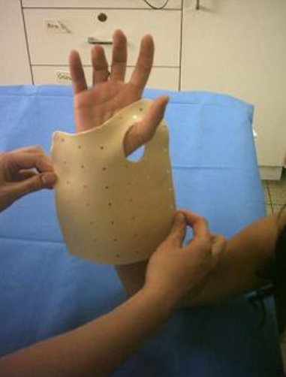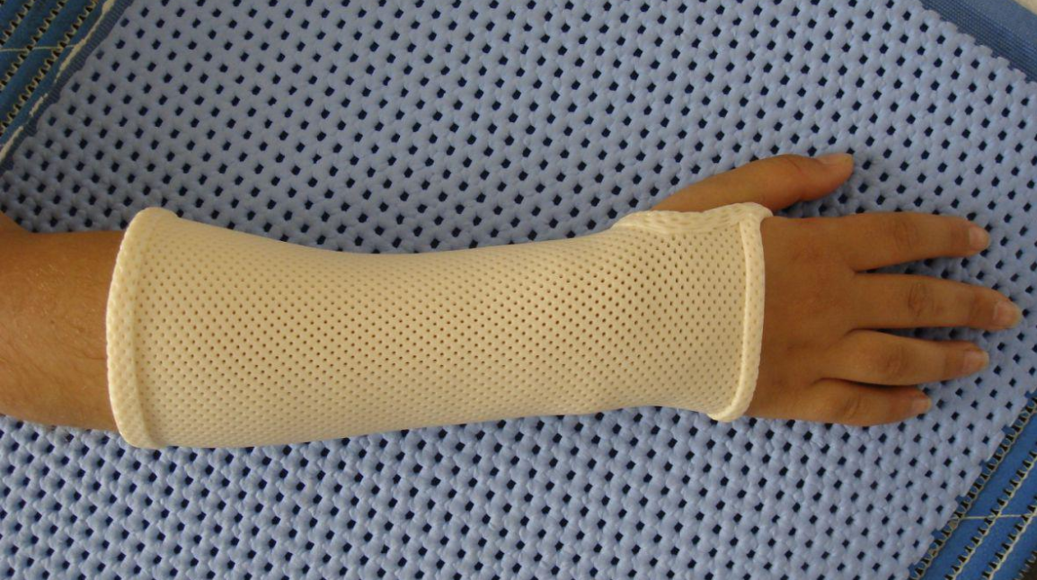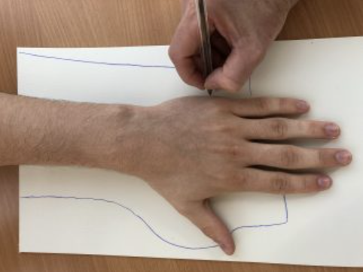

---------> --------->

*Picture 1 : Pattern of the orthosis Picture 2 : Moulding Picture 3 : Orthosis applied*

However, after making several splints by cutting into a thermoformable plastic plate, Mr FRANÇOIS throws away the remaining pieces of the plate that are too small to be used for another splint as can be seen in the photo below :

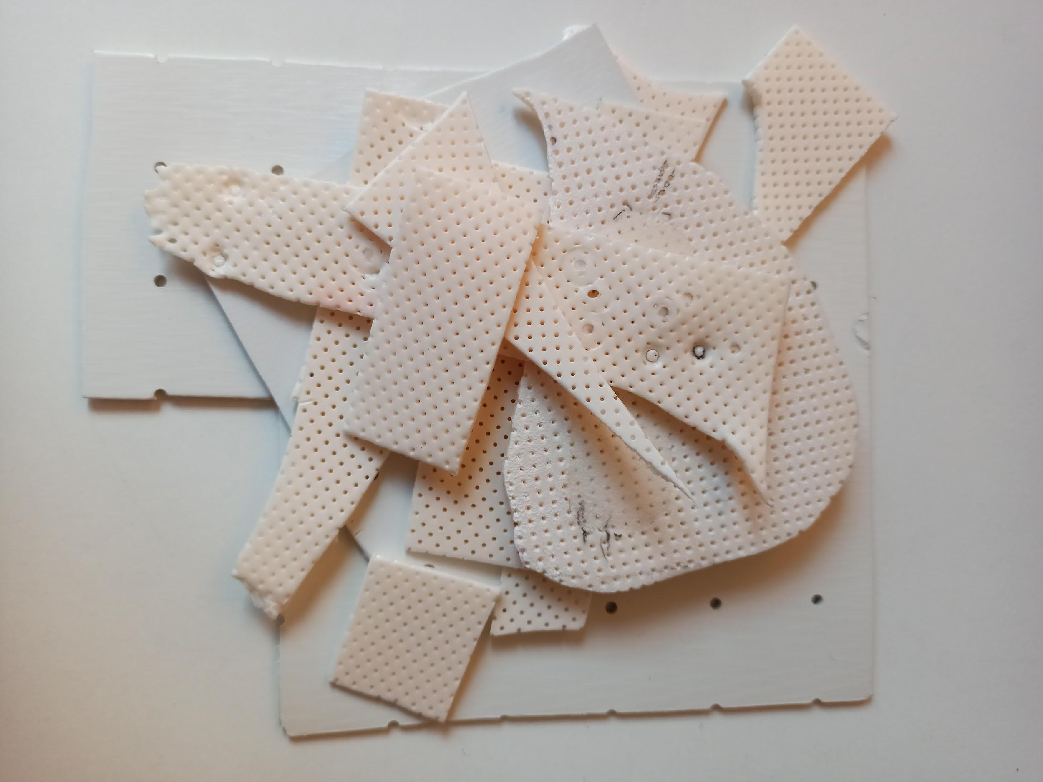

*Picture 4 :* Remaining pieces of the thermoformable plastic plate

So this is where our group can proffer solutions. Our aim is to shred these unusable pieces of thermoformable plastic using our low tech shredder and compress them, thanks to our low tech high temperature press, and make new thermoformable plastic plates. These new plates will then be given to Mr FRANÇOIS to make new splints.

# **Main objective of the project**

## Objectives for the shredder

As seen in the previous section, our low tech shredder will shred big plastic chips to facilitate the grinding at the FabMSTIC for our client. The figure below is a general view of the workflow regarding our low tech shredder :

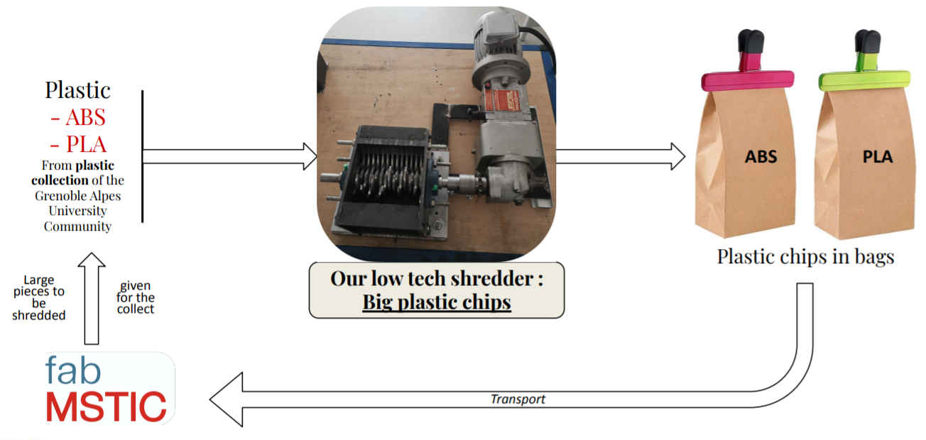

*Figure 6 : Overview of the project concerning the low tech shredder*

Concerning the design, the plan is to finish and make the shredder that **Guillaume Marin** gave to us, safe to use. To succeed we have some crucial points to work on :

* **SECURITY**

The first issue is Safety. To avoid injuries, we will develop two types of strategies: First, “Passive Strategy'' which refers to housings and a closer hopper to give access to the shredder’s blades and the moving part. Second, an “Active Strategy” which directly acts on the motor: a Captor stops the motor when the hopper is open. Moreover, a flashing light will shine when the shredder is in use.

* **ELECTRONIC**

Then comes the electronic part. In order to supply our three-phase motor with electrical energy, we use a converter which transforms a 230V single-phase current source into a 400V three-phase current between phases. Different buttons will be connected to this converter :

→ The end stop sensor used to secure the opening of the shredder.

→ An on/off button to start and stop the machine.

→ An emergency stop button, a potentiometer to vary the frequency and thus regulate the speed and torque of the electric motor.

→ A 3-position button to stop and start the shredder by rotating the motor forward or backward.

All these electrical components will be connected inside an electrical box to prevent users from having access to them and therefore promote safety. Finally two(2) indicator lights will be wired.

- A red light to indicate when the shredder is switched on

- A flashing light to indicate that the shredder is running (forward or reverse)

* **SUPPORT**

Finally, the shredder will be fixed on a rolling table. On this table, there will also be the motor on its support and a housing between the motor and the shredder to secure the transmission. A hole in the table will be made at the level of the shredder to let the pieces of plastic pass through and fall into a bottom installed below. Finally, the electric box will be fixed under the table like a drawer.

## Objectives for the press

The press intervenes in another part of the project; not the main client but the Physiotherapist. The figure below is a general view of the workflow concerning our Low-Tech Press:

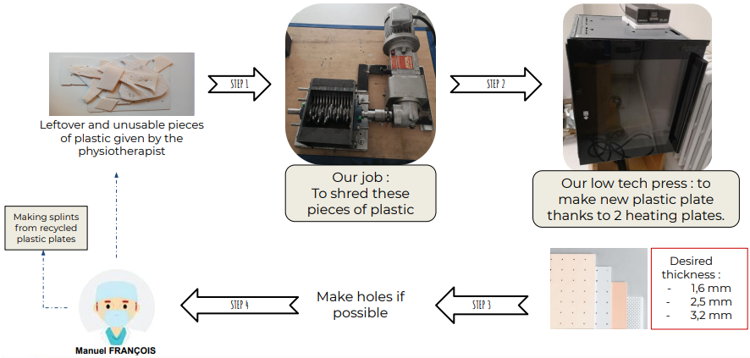

*Figure 7 : Overview of the project concerning the low tech press*

Concerning its design, we are not starting from scratch as Guillaume MARIN has given us the beginning of a prototype of an oven. However, this prototype is far from being complete and functional. That is the reason, at this stage of the project, we are thinking of starting almost from scratch to have a good basis and to make a system with two heating plates which will make it possible to compress the plastic in a homogeneous way and thus, form the plates.

In order to do this, there are several important issues that we need to focus on. Some of these crucial points are identical to those of the shredder :

* **SECURITY** (To secure the press and avoid accidents such as burns and vapor inhalation)
* **ELECTRONIC**

However, for this part of the project we will have to think about a whole different and important new point that we did not have for the shredder :

* **ENVIRONMENT/HEALTH**

Indeed, when plastics, and in particular ABS, are heated, tiny particles called *"ultrafine"* are emitted. It is therefore necessary to provide ventilation and/or filtration of the toxic gases emitted in order not to pollute the environment and to protect the health of people in the vicinity.

# **Delivery**

Let's begin with the final output of the shredder that we envisage at the end of the project. In order to meet the overall objectives specified in the previous section (SECURITY, ELECTRONIC, SUPPORT**)**, the figure below shows the schematic we made of its final prototype.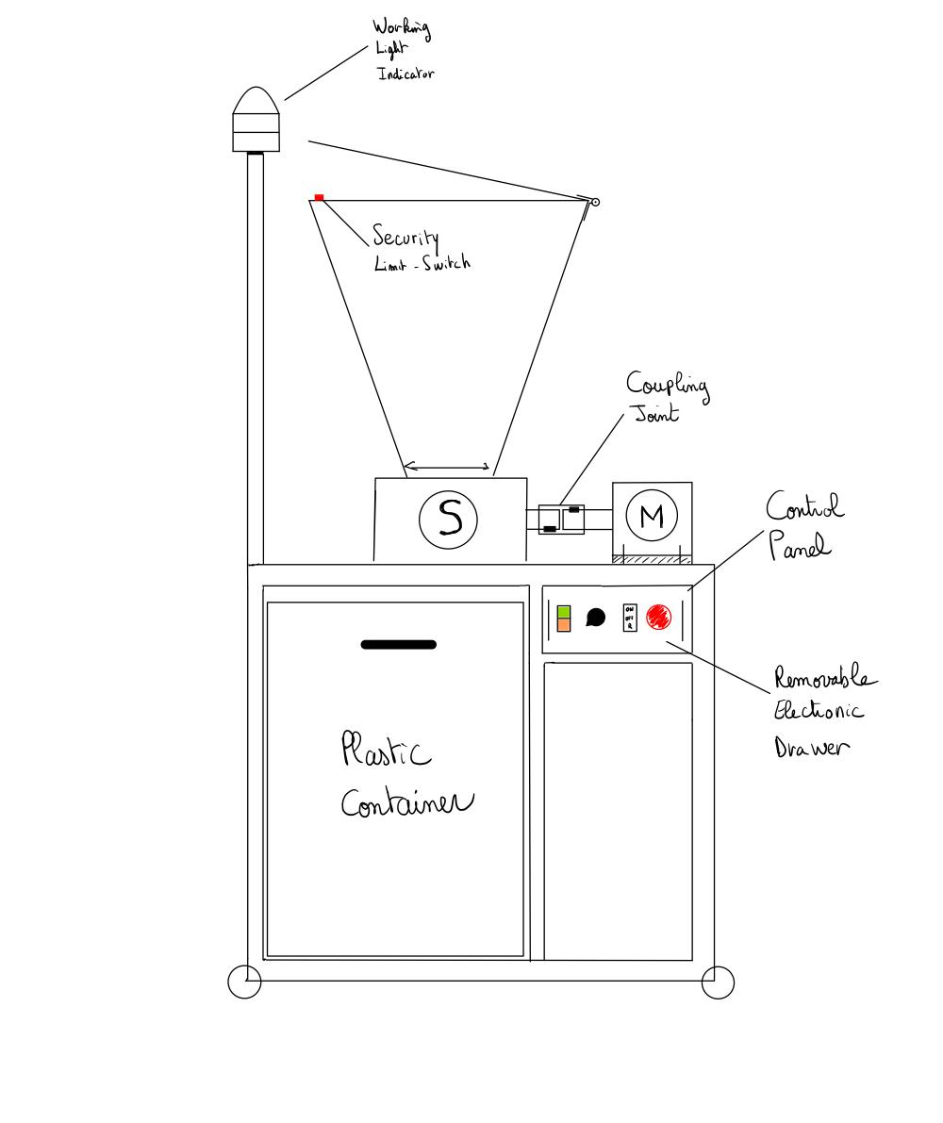

Now let's look in more detail at the objectives that the shredder must meet in order to satisfy the customer's requirements. Here are some extracts from the specifications :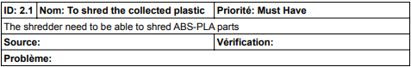











*Figure 8 : Schematic of the final*

*prototype of the shredder*

At the end of the project, what we will deliver to the client will not be the shredder itself but a functional shredder solution drived by the Rafu network and capable of shredding big chips of plastic into medium chips.

Now, regarding the hot press, we also have a first idea of a schematic for the prototype, but it is far from being as complete as that of the shredder, as we are still at the solution research stage (see Gantt chart in part F).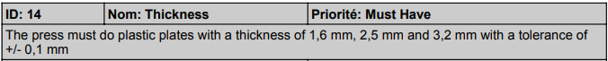

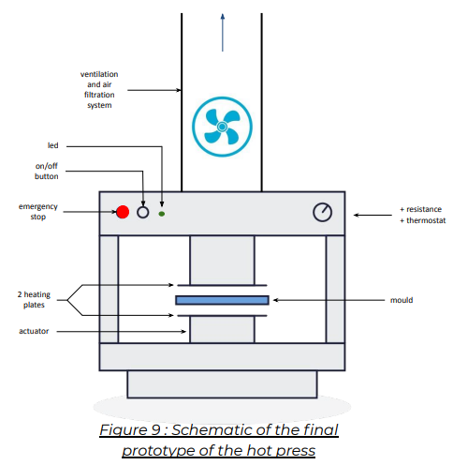







At the end of the project, as for the shredder, we will not deliver the prototype of our press to the Physiotherapist. However, the Hot Press will be functional and capable of making new plastic plates for the Physiotherapist. Moreover, the documents made with the press makes it reproducible for everyone who needs it.

# **State of the Art**

Our goal is to Recycle Plastic, but there are many different types of plastic, each with different characteristics, which means that they do not come from the same sources and cannot be recycled in the same way. It is therefore necessary to analyze these different plastics, their properties, their origin, their use in order to see how we can be the most versatile and recycle the most suitable type of plastic possible. (Data : [1])

| **Plastics** | **Characteristics** | **Hazards** | **Recycling** | **Sources** |
| --- | --- | --- | --- | --- |
| **PET (PolyEthylene Terephthalate)** | Rigid and hard, good mechanical resistance and low moisture absorption | Dangerous for your health! Releases *endocrine disruptors* into the water | 100% recyclable (but requires purity of recycled material) | Bottles of mineral water, sodas and fruit juices... |
| **PVC (PolyVinyl Chloride)** | Soft and flexible | Presence of *endocrine disruptors* | Not recyclable in most cities | Household items (shower curtains), vinyl, pipes, inflatables... |
| **LDPE (Low Density PolyEthylene)** | Made from petroleum,  Opaque or translucent | No known health problems | Few recycling facilities (to limited because it is hard to recycle) | Grocery bags, plastic packaging, garbage bags, tarps... |
| **PP (PolyPropylen)** | Strong and heat resistant | Considered safe for food use | Can be accepted in recycling facilities but often landfilled | Jars (yogurt, cheese, butter), tupperware, automotive industry... |
| **PS (Polystyrene)** | Petroleum based,  Breaks easily into small pieces | Dangerous, especially when burned (carcinogenic)  Pollutes our waterways | Generally not accepted in recycling facilities | Polystyrene (thermal insulation plates for the building industry), disposable cutlery, CD cases... |
| **PLA (PolyLactic Acid)** | Of vegetable origin,  Mixture of several plastics |  | Compostable and not biodegradable -> lack of infrastructure to compost it (ends up in the landfill) | 3D printers... |

**Endocrine Disruptors:** substances that mimic the role of hormones and disrupt their proper functioning.

After talking about the different types of plastic that are mostly found in landfills, we will detail here the few technologies used to recycle plastic in a low-tech philosophy :

* **Shredding :** 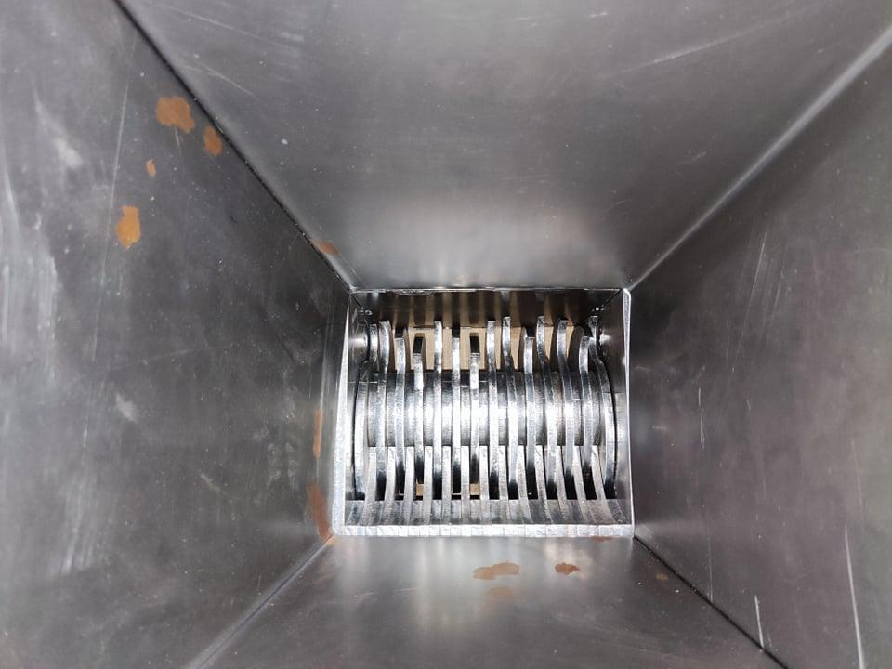

Shredders cut plastic items into small flakes ready to be turned into new things by the other machines, very useful for reducing the size of products to be recycled . The functioning of the shredder is quite simple, depending on the size of the parts to be shredded, we use one or two blade rollers as shown on **Figure 10**. The manufacture of such a shredder can be done by cutting sheet metal, which is an efficient and cheap solution, an important point for us. The only part that can be expensive if bought new is the motor needed to drive the knives, it needs to be powerful enough to shred.

*aaiFigure 10 : Example of cutting*

*blades on the existing shredder*

* **Drying :**

After having our flakes using the shredder, we can add a step to the recycling process ; drying. This step is not essential but preferable to ensure a better quality of the future molten plastic. In fact, often, moisture appears in plastics due to the humidity of the environment to which they have been exposed, this finally reduces the properties of the recycled materials. A low-tech and existing solution to dry plastic chips is to use an air exchange oven, this is certainly not the best solution but the most affordable. Industrial and expensive machines actually use a kind of “pop-horn” technology, the idea is to put plastic chips in a hopper and to blow hot air inside as shown by **Figure 11**. More locally, the Ginova platform is equipped with a machine of this type which we can use to dry out plastic if necessary.

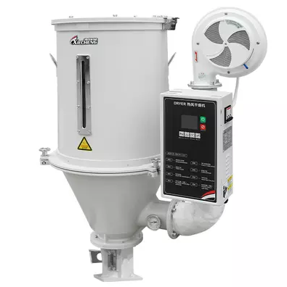

*Figure 11 : dehumidifier dryer from jm xiecheng [2]*

* **Compacting and Melting :**

The function of the compactor in our recycler is to transform small pieces of crushed plastic into molded plastic plates. For this purpose there are already several solutions, but the idea remains the same: the small pieces of crushed plastic are placed on an aluminum plate (or in a mold), the environment is heated to the melting temperature of the processed plastic (oven or hot plates) and the plastic is compacted with the help of a second plate. 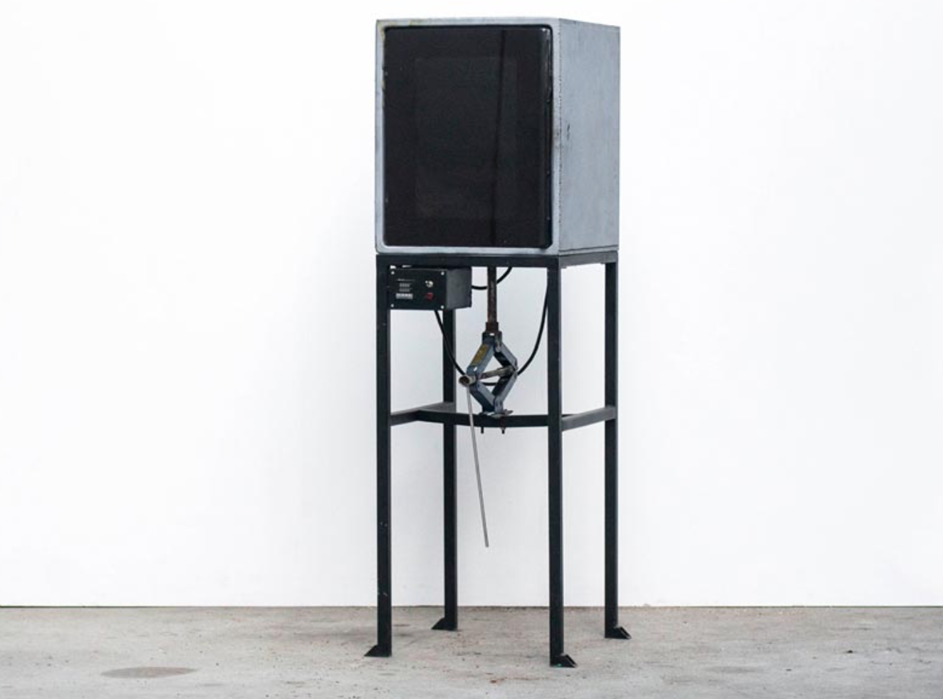

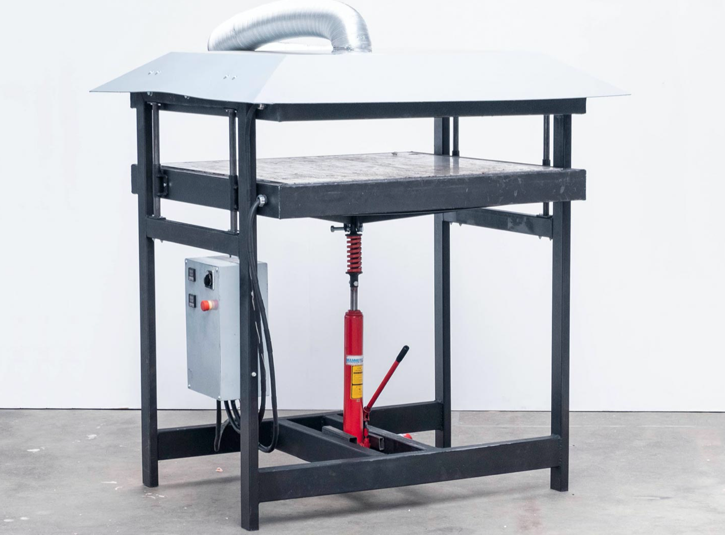

*Figure 12 : Pro Sheetpress [3] Figure 13 : Basic compressor [3]*

Here we can see (*Figure 12&13*) two different solutions for this "compressor". Indeed, figure 12 is one of the best current options to do what we expect from our press, we can see that it is made so that the plastic (located on the lower plate) is compressed by the upper plate by a hydraulic press. The two plates are heated with resistances. We also notice that there is a smoke evacuation for safety because as seen previously, some plastics are dangerous for health and their filtration is necessary to avoid their inhalation and thus to handle the plastic without danger. In the second case (figure 13), much more low cost, plastic is heated inside the oven and slowly pressed into a mold with a carjack. Our goal is to be inspired by both methods in order to be as efficient as possible, at a price that is always affordable and, above all, while maintaining the necessary security.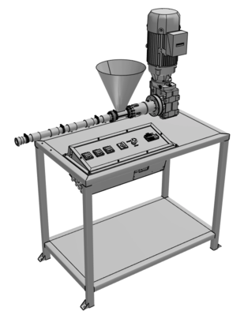

* **Injection :**

Finally, another affordable way to recycle plastic is injection molding. The shredded plastic is thrown in the machine hopper, after that, the plastic is heated and then passed through a pipe with an endless screw system to obtain molten plastic under pressure at the outlet. We can then place our mold at the outlet and make all types of parts. Again, precious plastic proposes open source, affordable, machines plans (**Figure 14**).

*Figure 14 : Extrusion Pro V1 [3]*

*from preciousplastic*

After having presented the different technologies for plastic recycling, what are the different objects, services that we could render with such tools keeping in mind a “low-tech” philosophy? This is the question we will try to answer:

3D printing is now at the heart of many projects for prototyping and is an asset for its ease of use, the possibility of using different materials to make parts for different uses, particular filling structures, complex shapes,etc. When using 3D printing for prototyping, we realize that we generate a lot of plastic waste ; ABS (for The Ginova platform) and PLA (for The FabMstic) for example, are the two materials mainly used in 3D printing. The big problem is that, to date, we throw these waste directly into the trash, which is a shame because on the scale of a school (that does a lot of prototyping), this represents a lot of lost material.

The first idea is to use the technologies presented above to remanufacture filament and to be able to reprint with it again (shredder, dryer, filament maker). This is in fact the main objective of our customer Germain Lemasson, who already has the three machines proposed by 3Devo (**Figure 4**); he is able to remake ABS and PLA spools and put them back into circulation. This solution would also allow the manufacture of non-standard additivated filaments with aluminum, wood chips, PET, nylon and others. But buying this set of existing machines represents a significant investment, which therefore takes us away from a low-tech proposal.

Another possibility is the realization of plastic plates from different materials for different purposes:

* Plastic plates to realize any type of objects of decoration, furnishing, kitchen, etc. Many examples are available on the preciousplastic [3] website, see the chair example below (**Figure 15**).

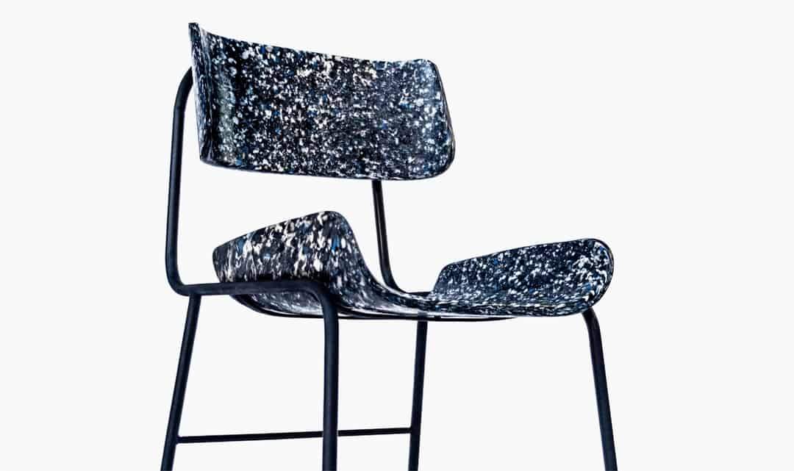

*Figure 15 : A chair, made of recycled plastic plates*

* Laser-cut PLA plates for prototyping
* PLA plates for physiotherapists, with the right thickness and regularly perforated with a laser cutter: they allow to make ortheses similar to those used in hospitals with a special plastic. The current problem is that this material is expensive and is not recycled after use to make new plates. The use of recycled PLA would therefore reduce the cost of orthotics for a similar use.

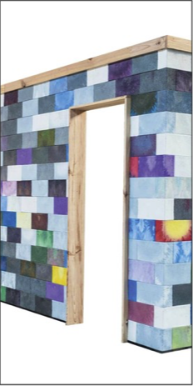

Finally, we can make injected plastic parts with the injection machine presented before to make useful parts. This is the idea of the french startup SAMJI [3], this company wants to manufacture bricks, but not conventional bricks, we are talking about 100% recycled plastic bricks from waste. They can be used to make partitions in houses, garden sheds… (**Figure 16**)

*Figure 16 : a brick partition from SAMJI [4]*

# 

# **Workplan**

In order to carry out such a project properly, one of the first steps is to make a Gantt chart. This Gantt created on a google sheet shows the tasks to be carried out, their duration and the resources allocated to them (6 in our project). It allows us to monitor the progress of the project and check that tasks are not taking too long to complete. If some delays do not impact the project, the tasks on the critical path must be completed on time to avoid impacting the final project completion date. For our project, this is the case for tasks I and N, for example, which consist in improving the prototypes given by Guillaume Marin at the beginning of the year. In addition, we have indicated the exam dates in order to anticipate these busy weeks and get a head start in the weeks leading up to them. The figure below shows an extract from our gantt :

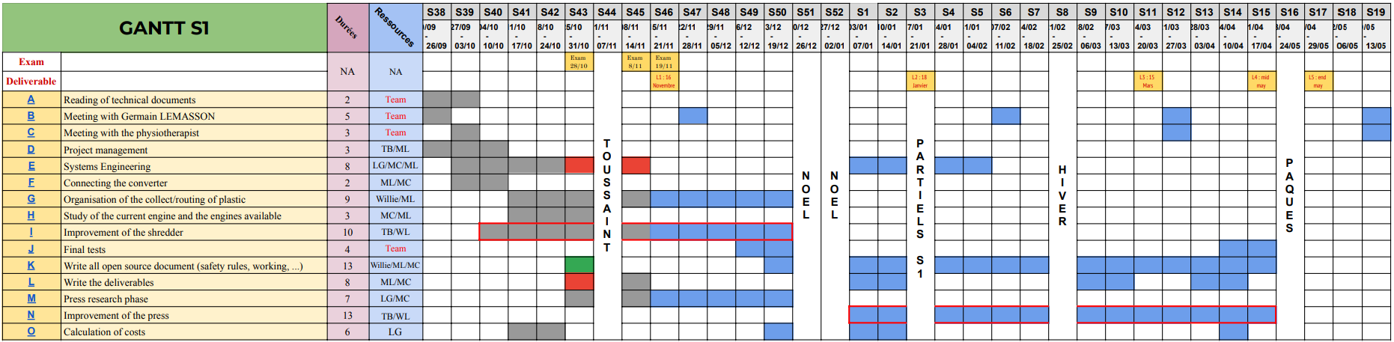

*Figure 17 : Gantt REV1 of the ‘Open source plastic recycling machine’ project*

As can be seen in the figure, our Gantt has a total of 15 tasks to be completed in order to successfully finish the project. Each task is then detailed in a google sheet, as shown in the figure below, describing the different sub-tasks to be done and their progress. Let’s take the example of task N :

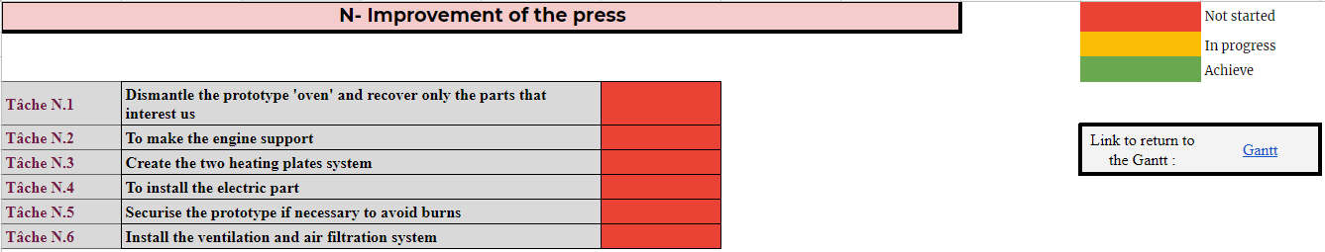

*Figure 18 : Details of the task N : Improvement of the press*

Task N is therefore divided into 6 sub-tasks which have not yet been started because they are planned for after Christmas in the Gantt.

In terms of our overall organisational strategy, we decided to start by focusing 100% on the shredder, with the aim of completing it by Christmas. Just before the ‘Toussaint' holiday, 2 people from the group are detached from the shredder to focus on the research needed to complete the press (Task M). After Christmas, others join them on the press and its prototyping phase will be launched (task N) and will continue until the end of the project. This task is the longest of the project because we are starting almost from scratch in contrast to the shredder, as the ‘oven’ prototype needs to be completely revised.

# **REFERENCES**

[1] ‘**Les différents types de plastique**’, octobre 2020, article from a website, https://www.another-way.com/blog/types-de-plastique/

*[2]* **Jm XIecheng company**, Industrial website, [www.jmxiecheng.com/drying-dehumidifying-series.html](https://www.jmxiecheng.com/drying-dehumidifying-series.html)

*[3]* **Precious Plastic community**, website, *preciousplastic.com*

*[4]* ***Atelier SAMJI startup****, website,* [www.kisskissbankbank.com/en/projects/atelier-samji-du-dechet-a-l-objet](http://www.kisskissbankbank.com/en/projects/atelier-samji-du-dechet-a-l-objet)